**CASE STUDY: 03**

**Deploy any Spring Boot REST API CRUD in Jenkins**

* **Create and Run Spring Boot Project.**

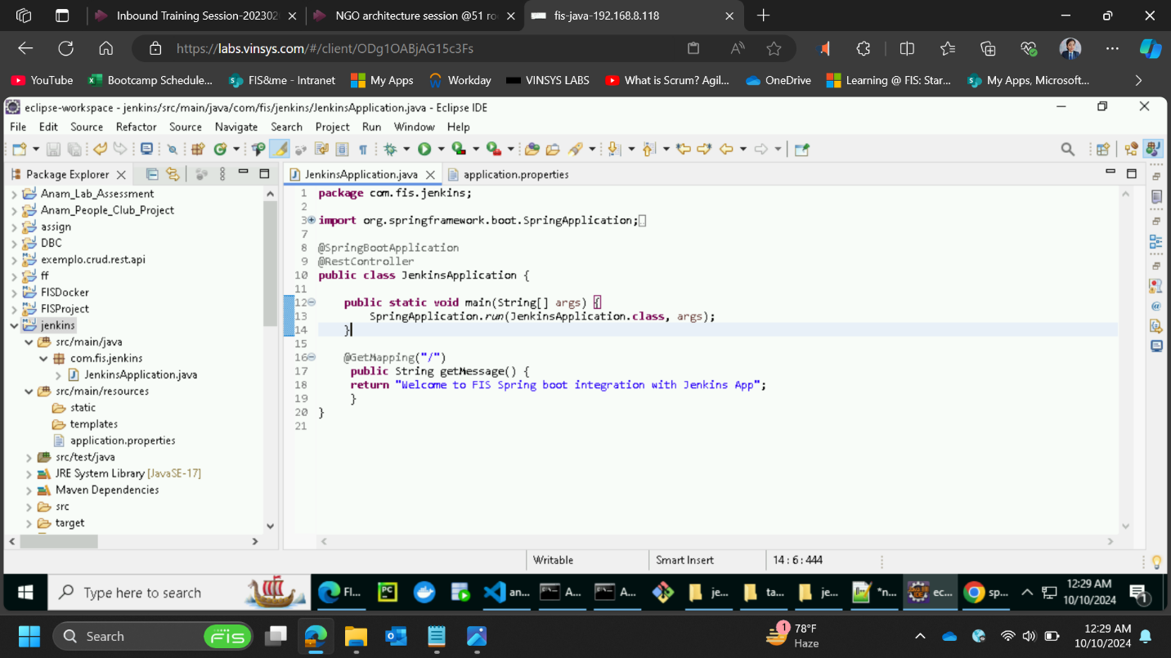

* **application.properties file:**

* **Set Up Jenkins and integrating it with GitHub repository**

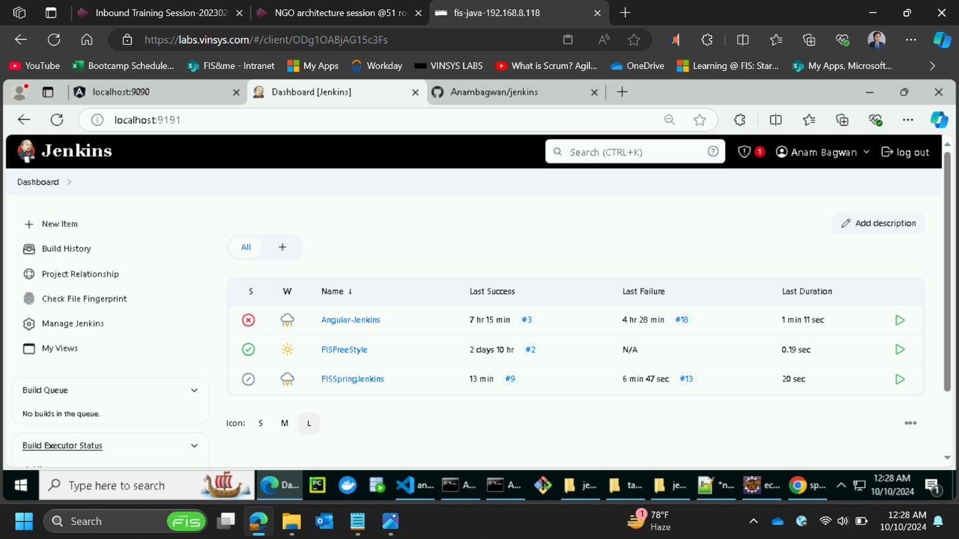

* **Run the springboot app on Jenkins port specified:**

